

**Submitted by: Submitted to:**

**NAME: Rahul Gusain Hitesh Kumar Sharma**   
 **SAP: 500084143**  
 **ROLL NO.: R214220900**  
 **BATCH: 1 DevOps**

EXPERIMENT 8

**AIM: Working with Docker (Basic Commands)**

**Steps to Complete:**

**Run Kubernetes service from Docker Desktop**

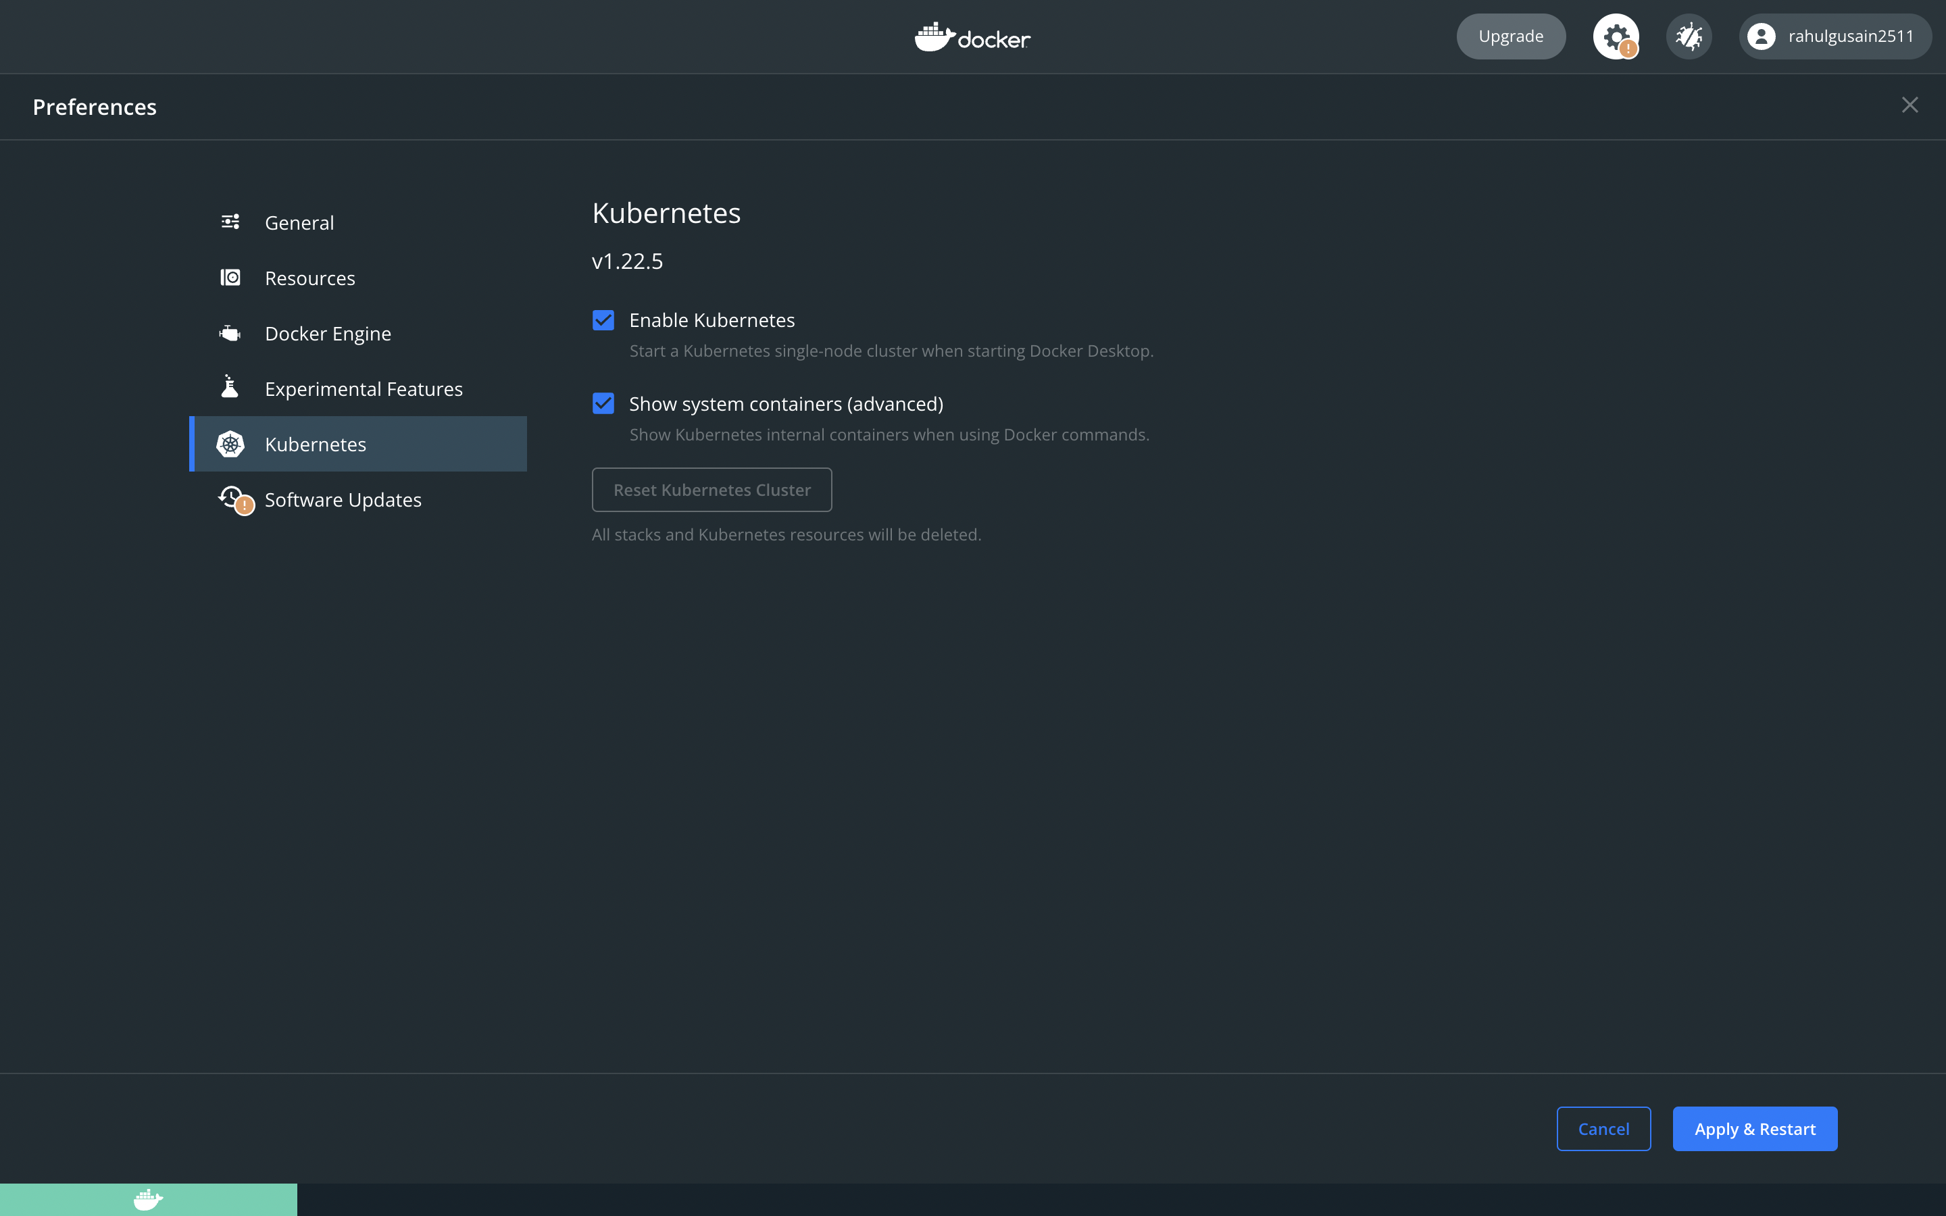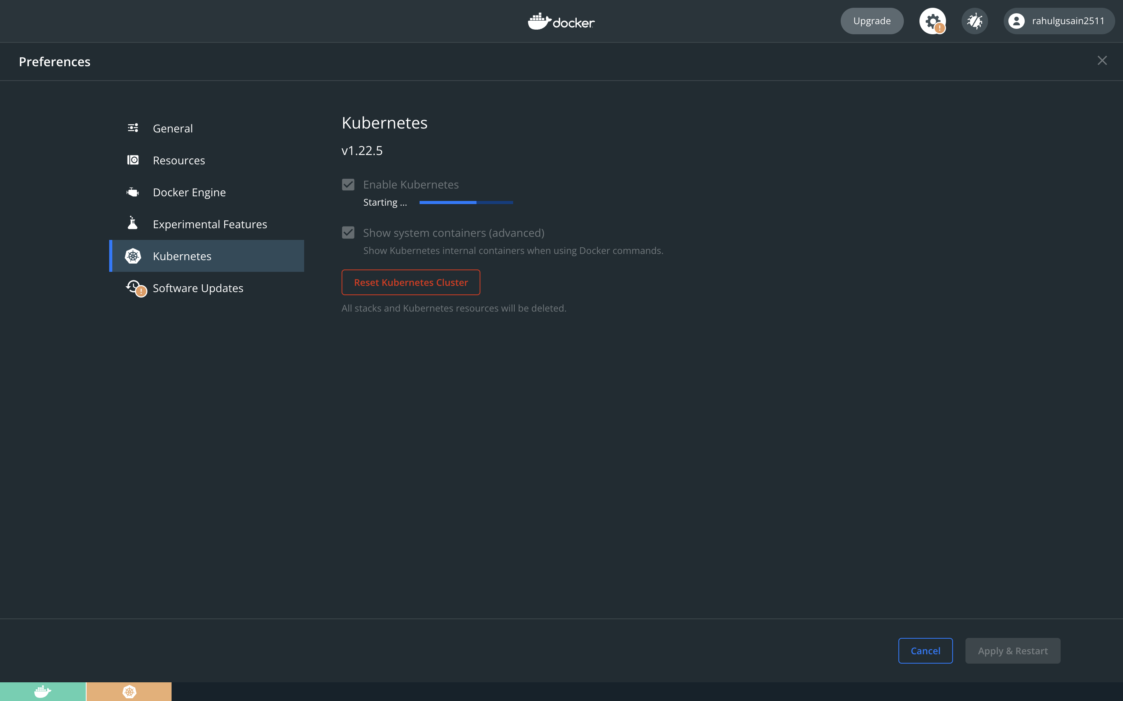

**Check for all running pods using commands in terminal** 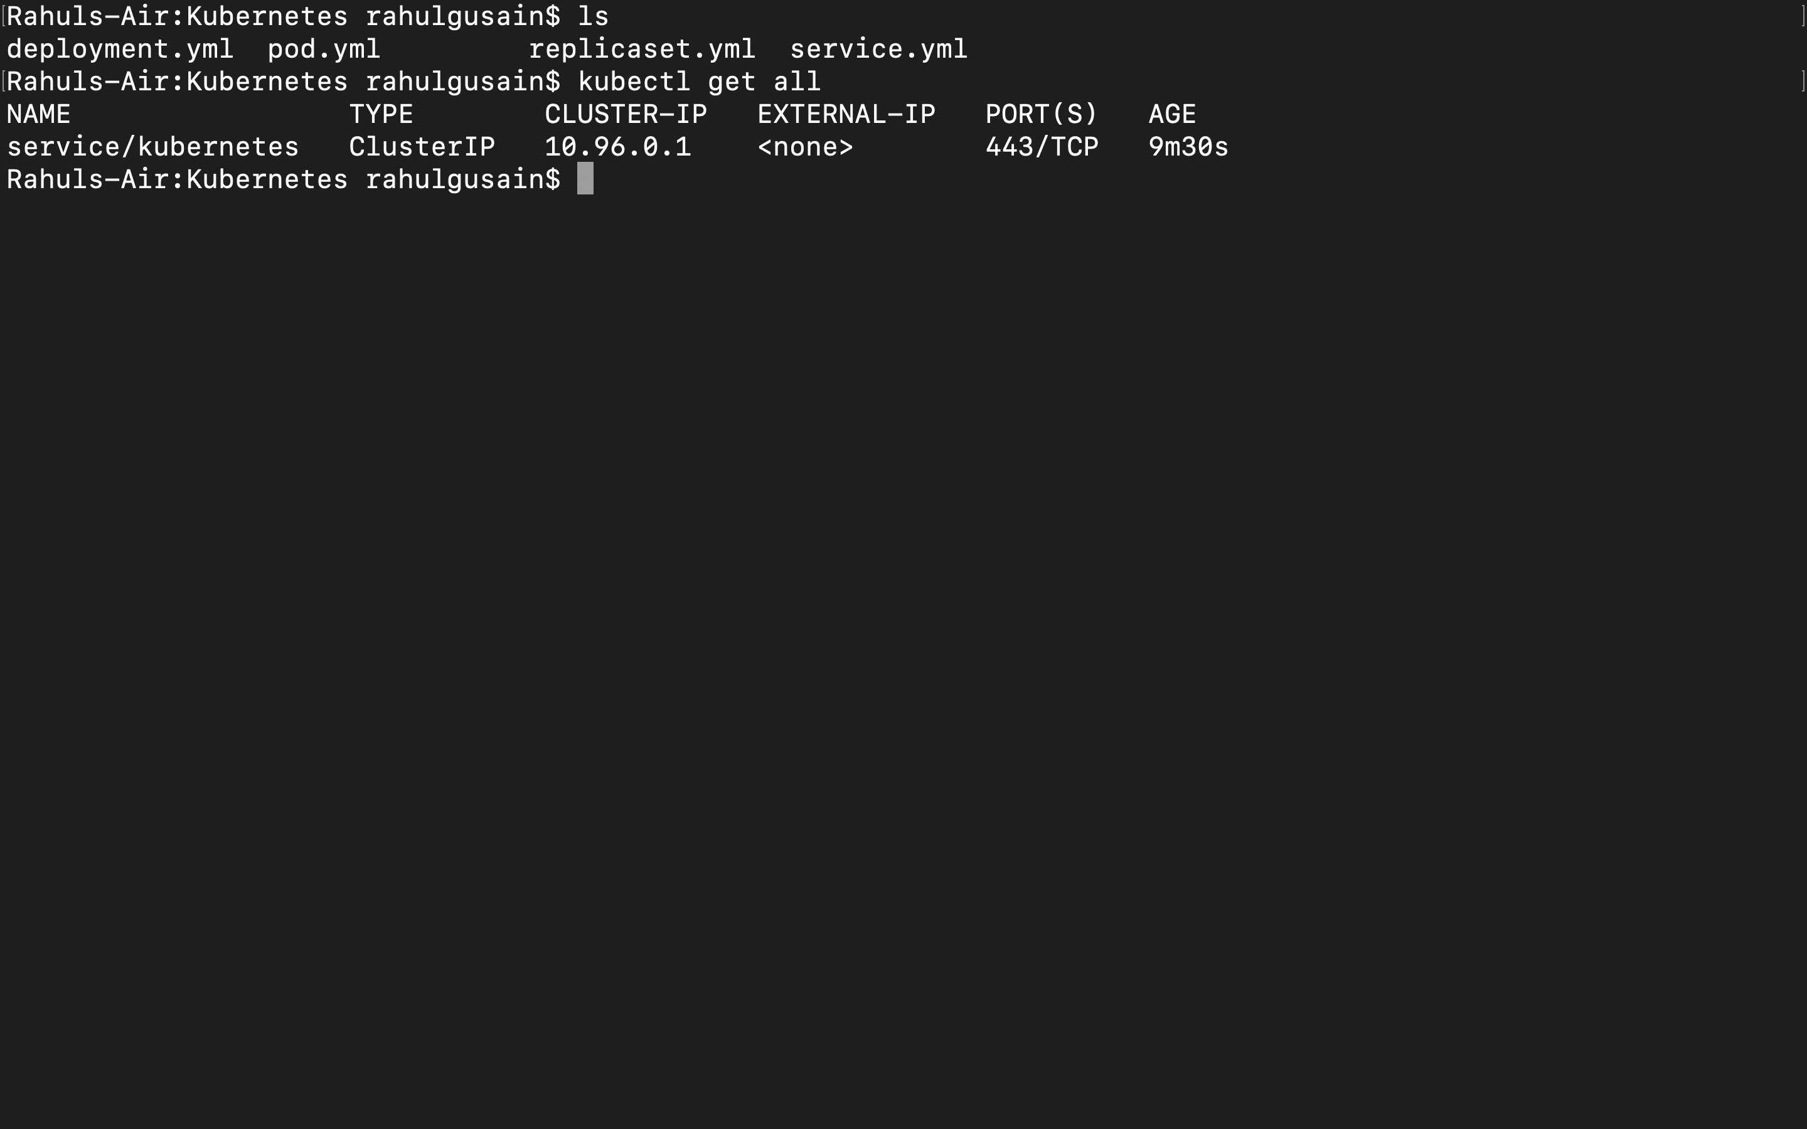

**Create a pod**

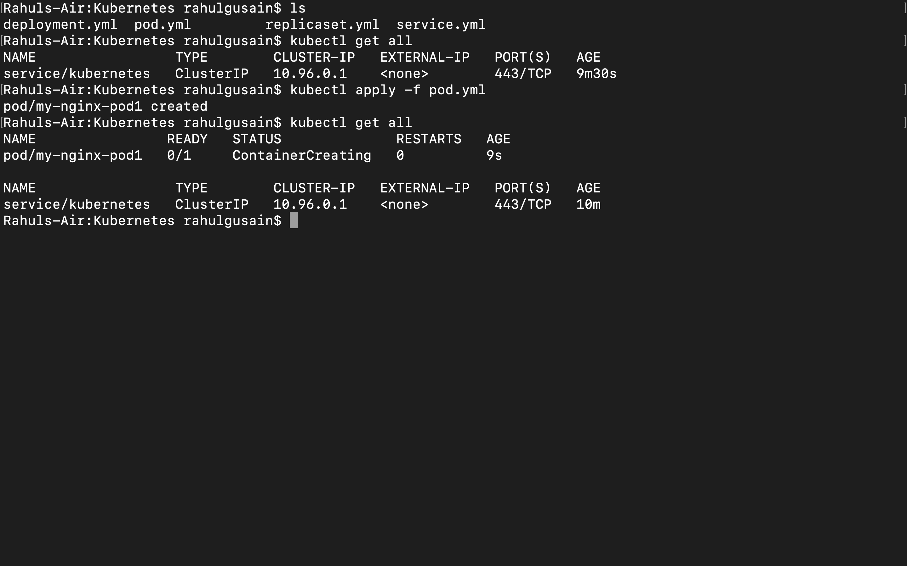

**Run replicaset.yml file to create replica of the existing service**

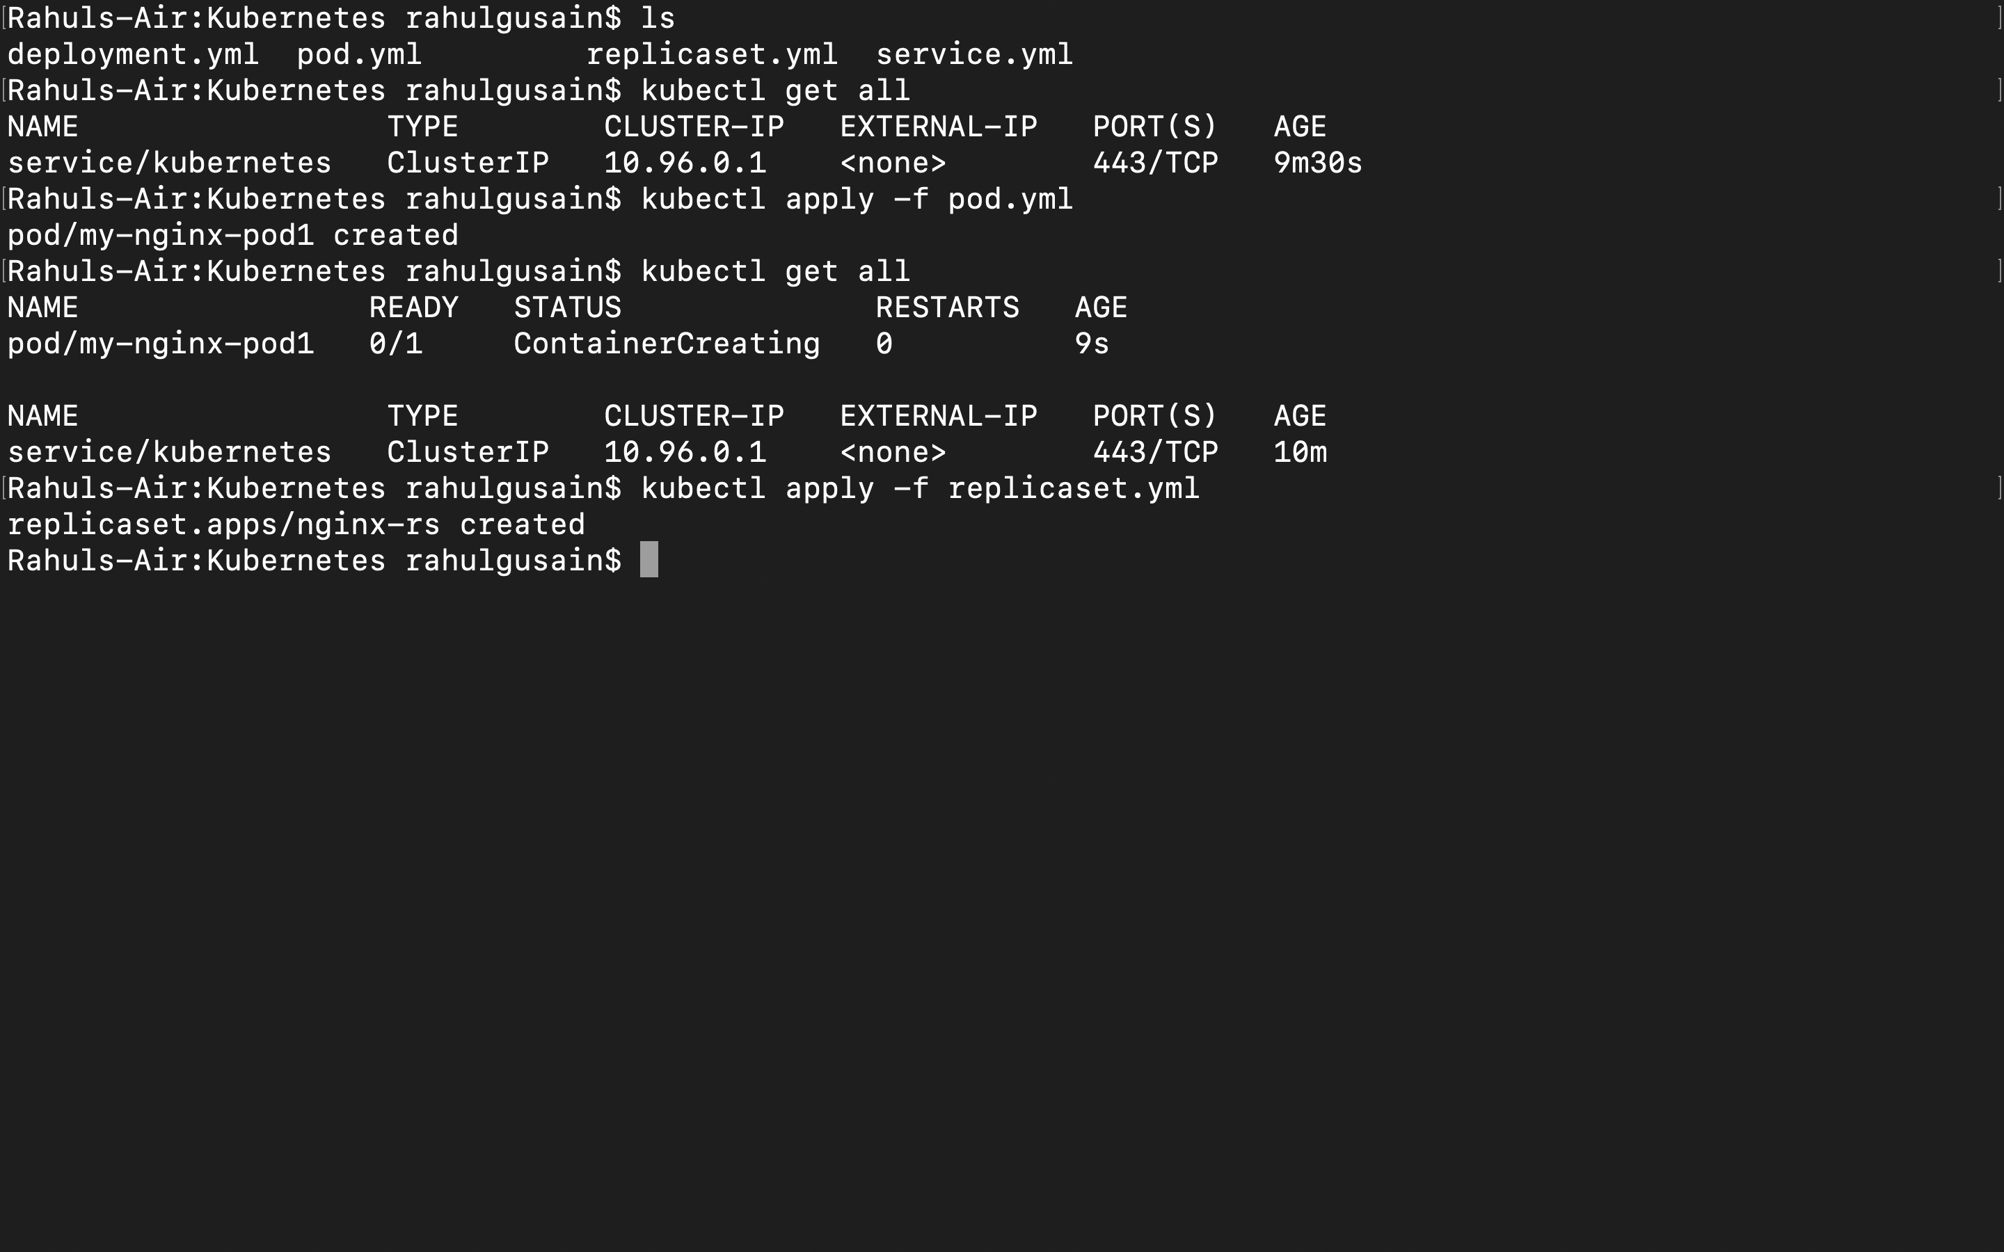

**Check for all running pods**

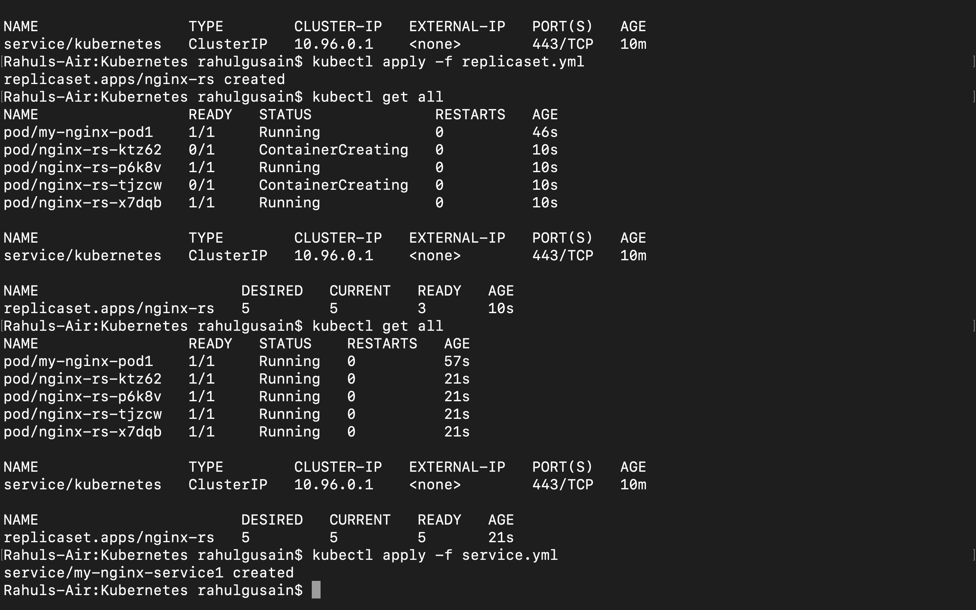

**Run service.yml file to create service**

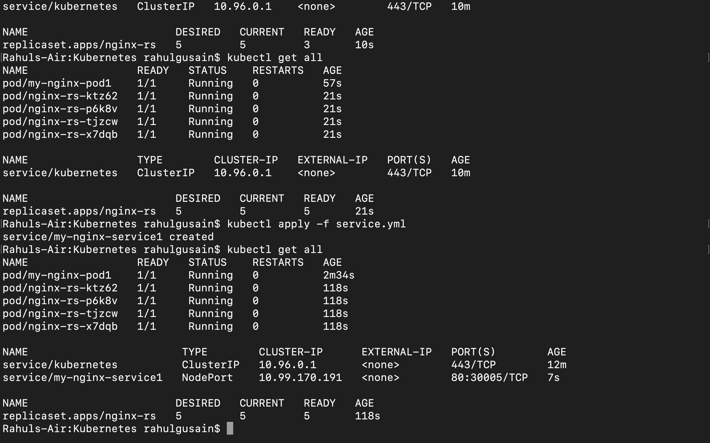

**Delete replicaset.yml to delete and stop all replicated services and then check for all running pods**

